Screen Shots Created
Here are the screen shots for implementing Simple EJB Project (Stateless Sessions Bean)

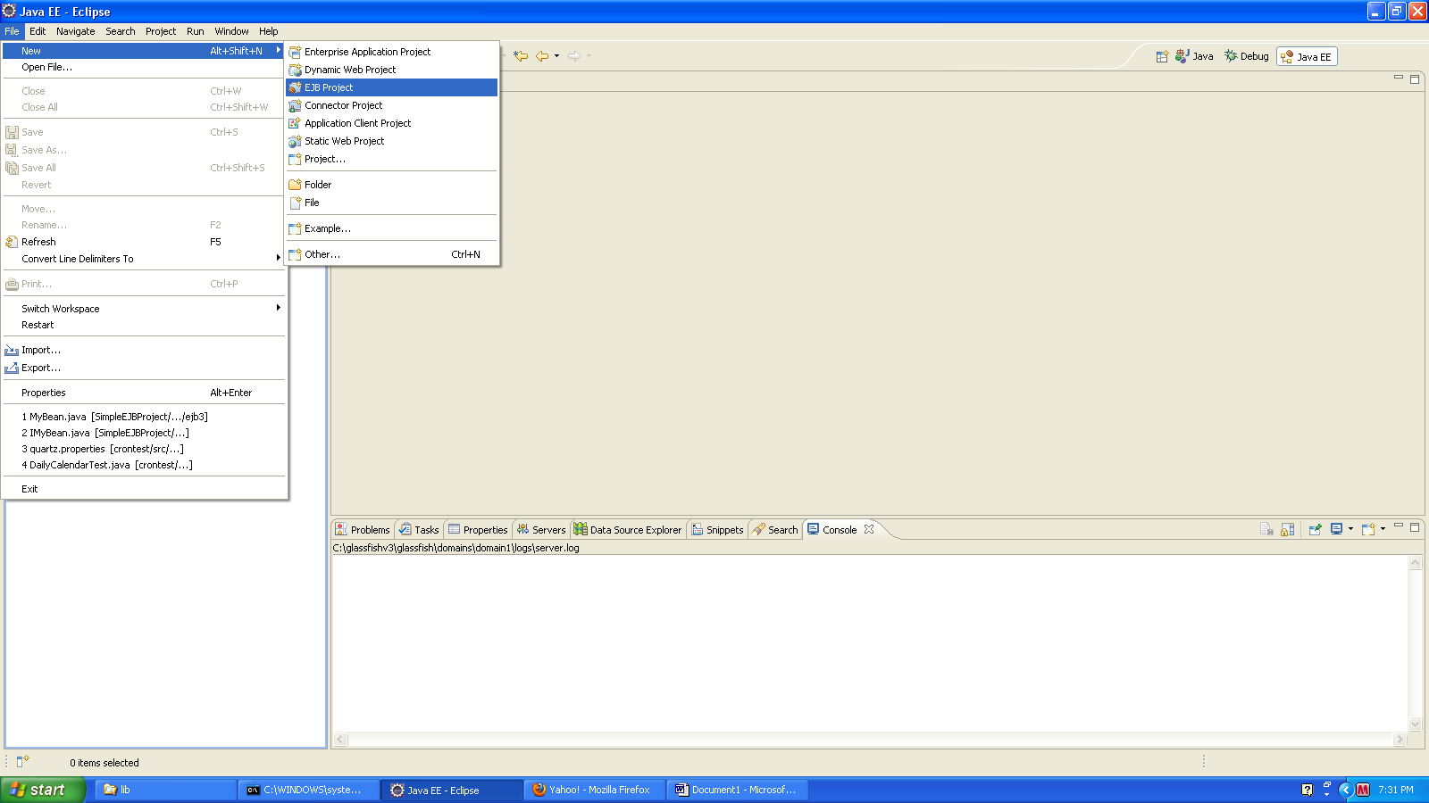

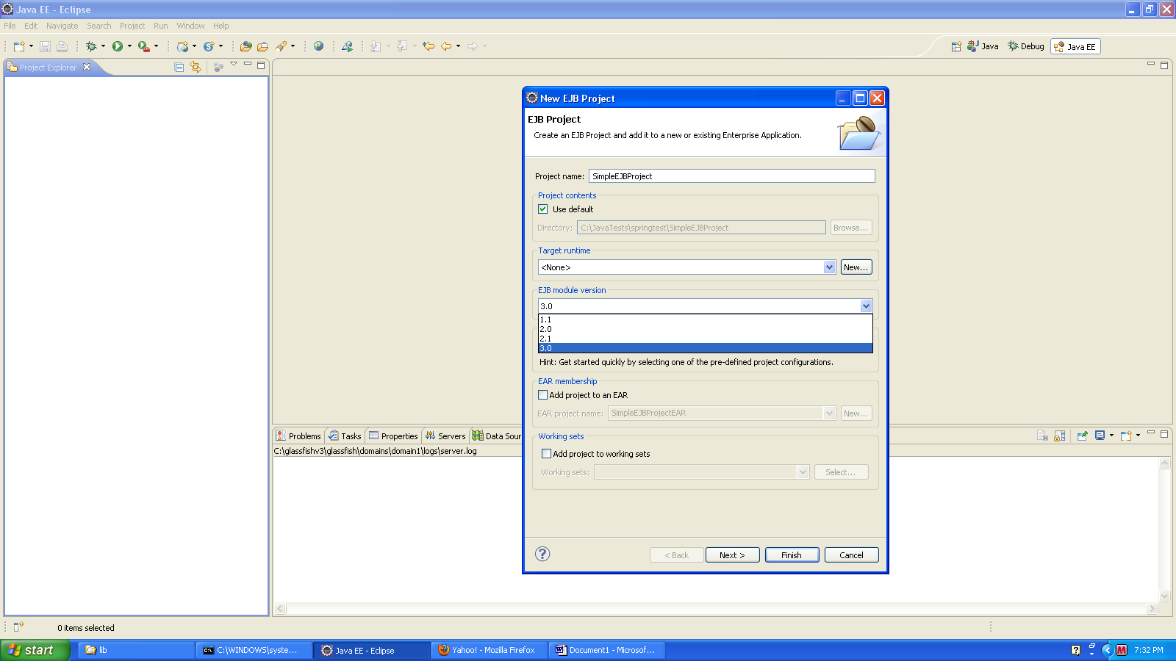

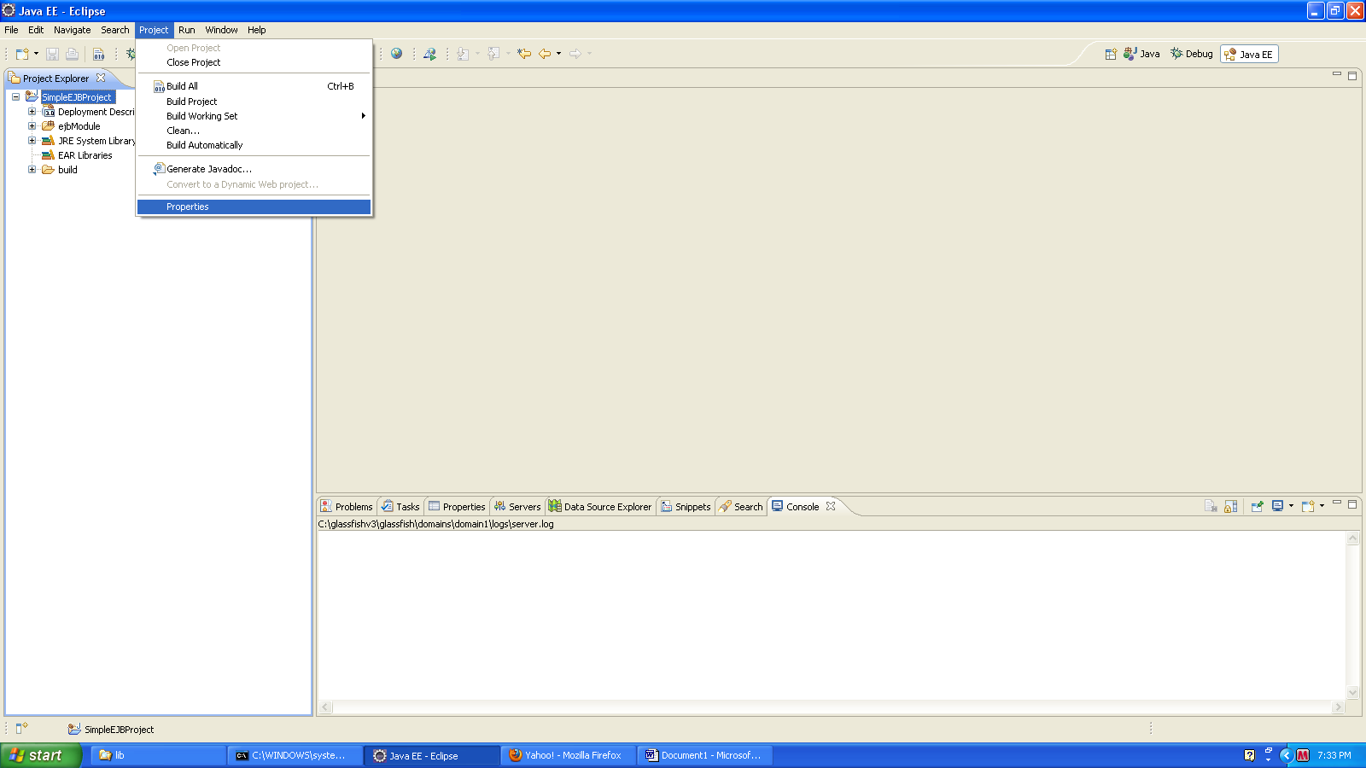

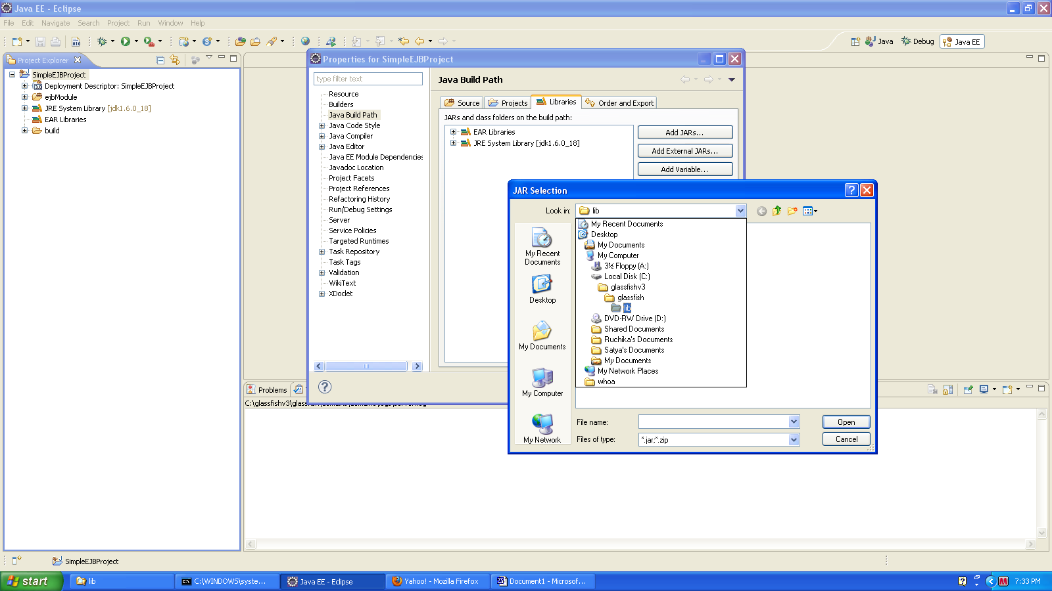

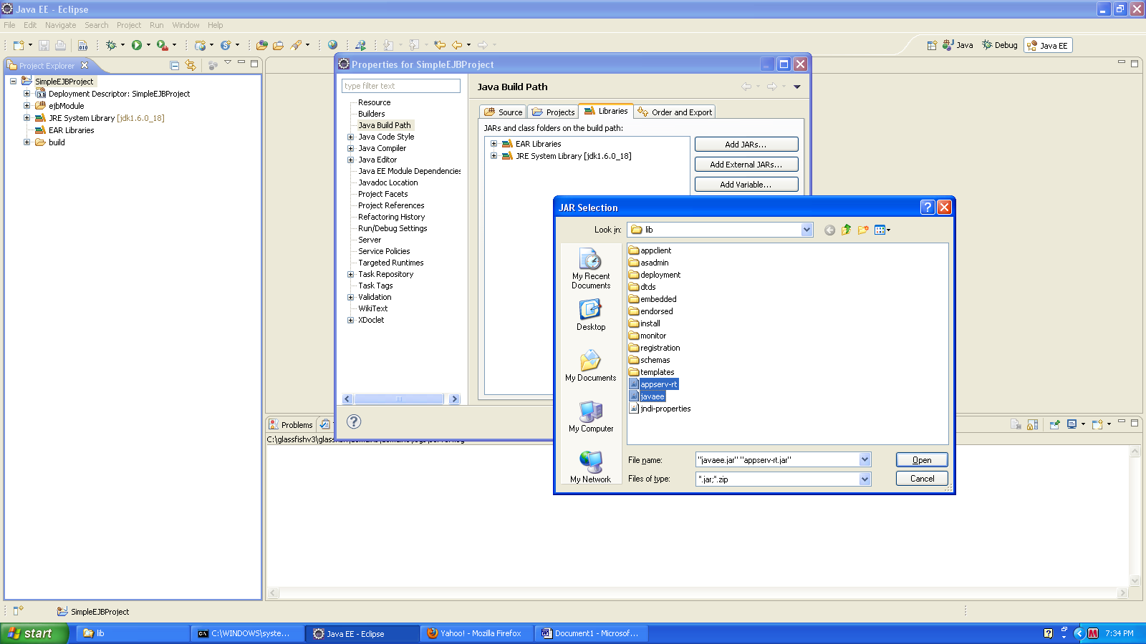

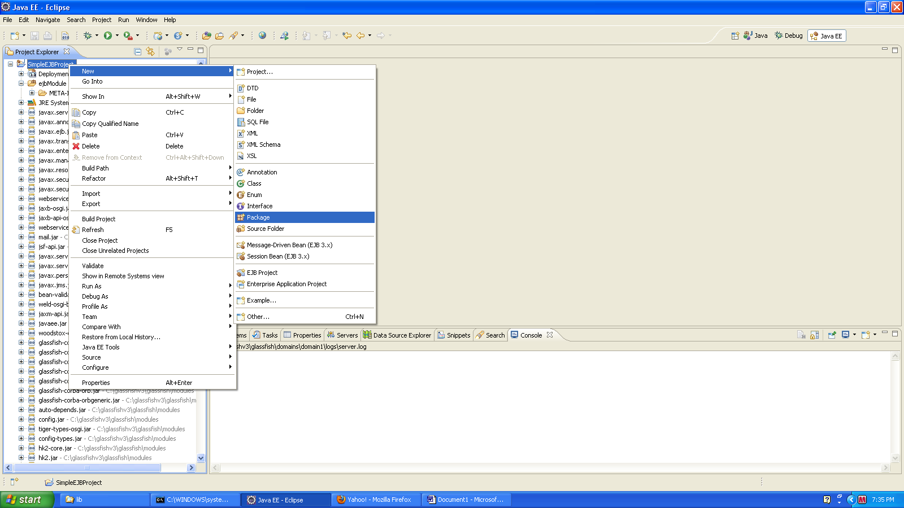

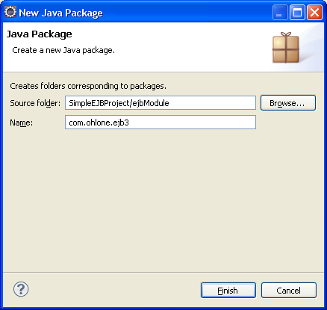

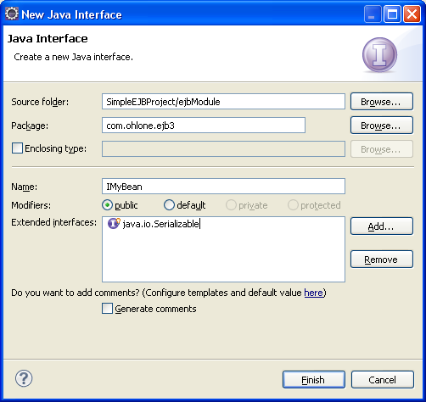

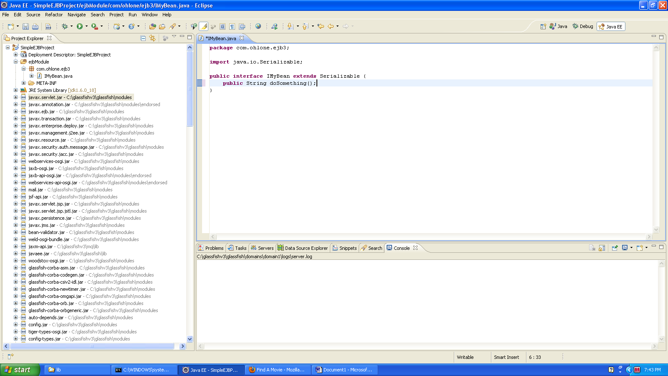

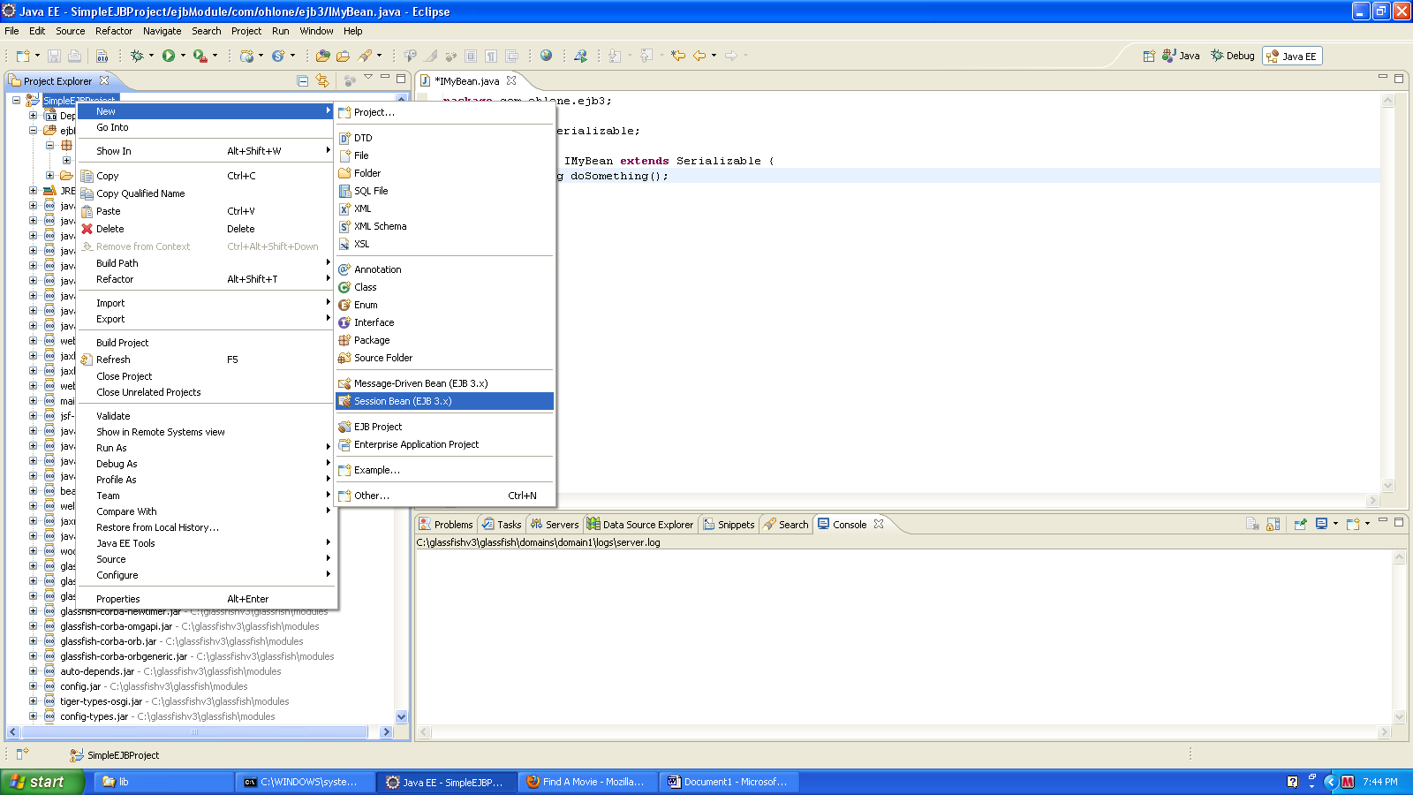

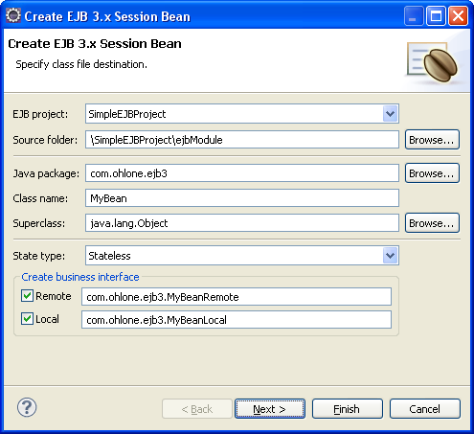

Add the highlighted text in MyBeanLocal.java and MyBeanLocal.java to extend iMyBean.java interface
Public interface MyBeanRemote extends IMyBean
Public interface MyBeanLocal extends IMyBean
Add the highlighted text in MyBean.java
@Stateless (name="MyBean", mappedName="ejb/MyBeanJNDI")

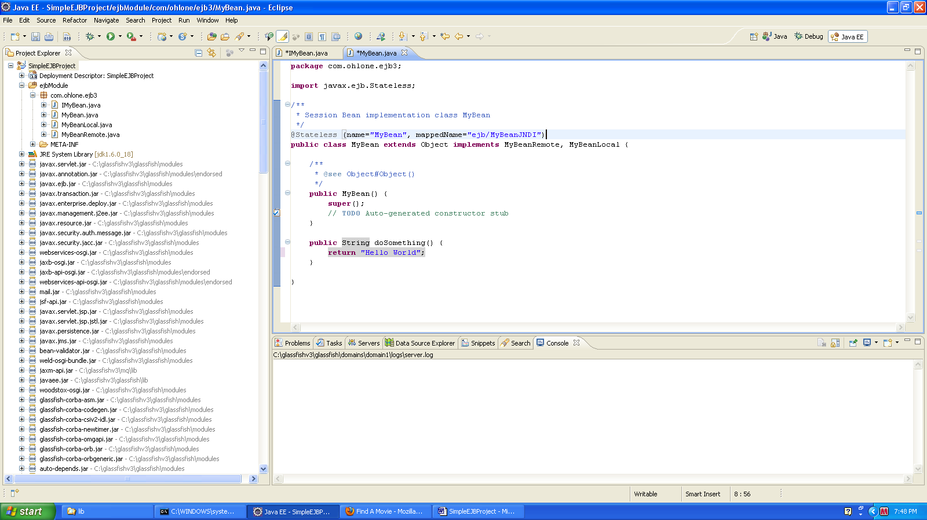

Start Glassfish and Deploy the application

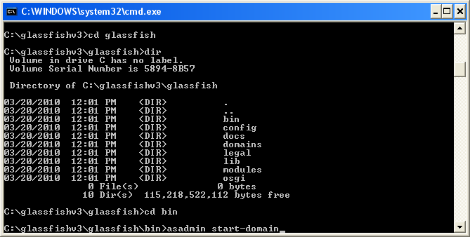

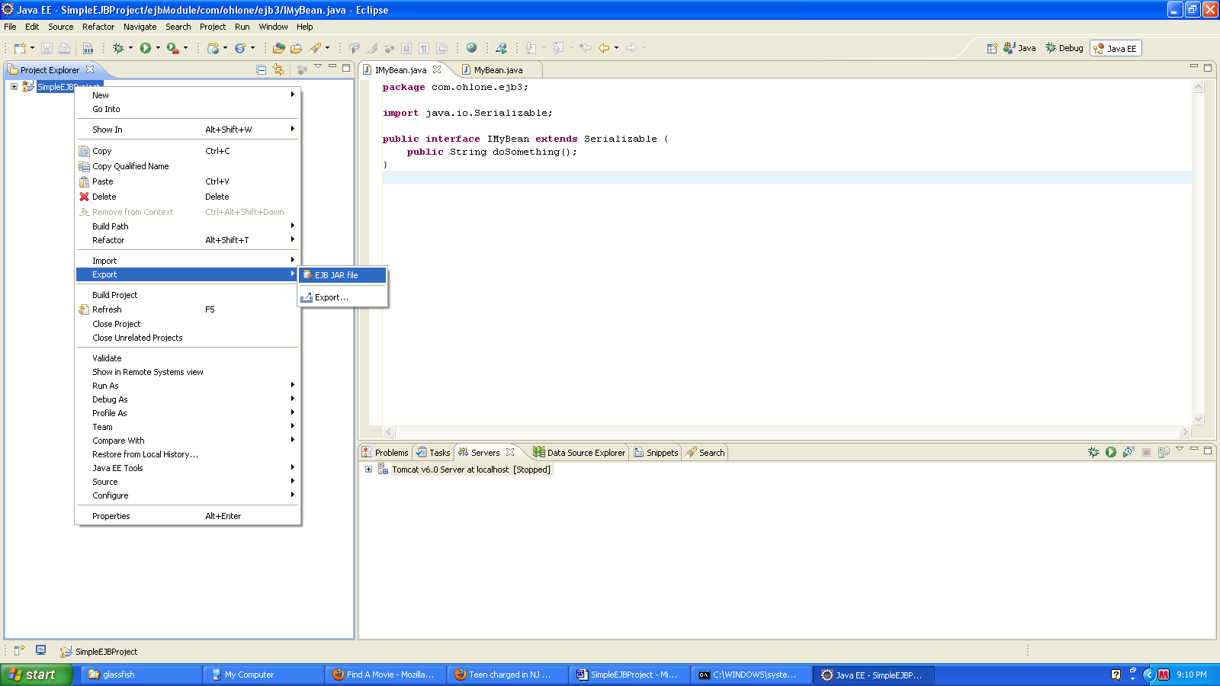

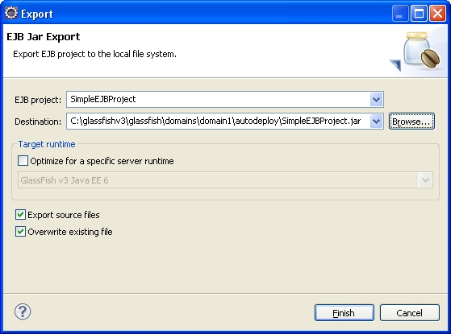

CREATE A NEW CLIENT PROJECT

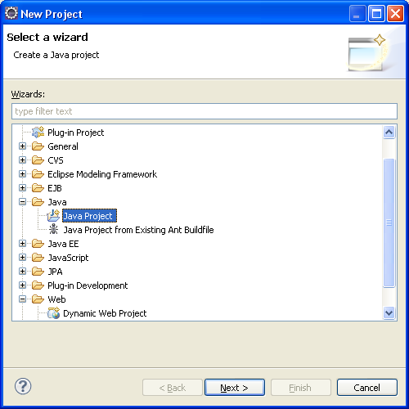

CREATE 2 Interfaces (MyBean.java & MyBeanRemote.java) You can drag both the interfaces from SimpleEJBProject and then refactor (rename) MyBeanLocal.java to MyBean.java and remove the extends IMyBean
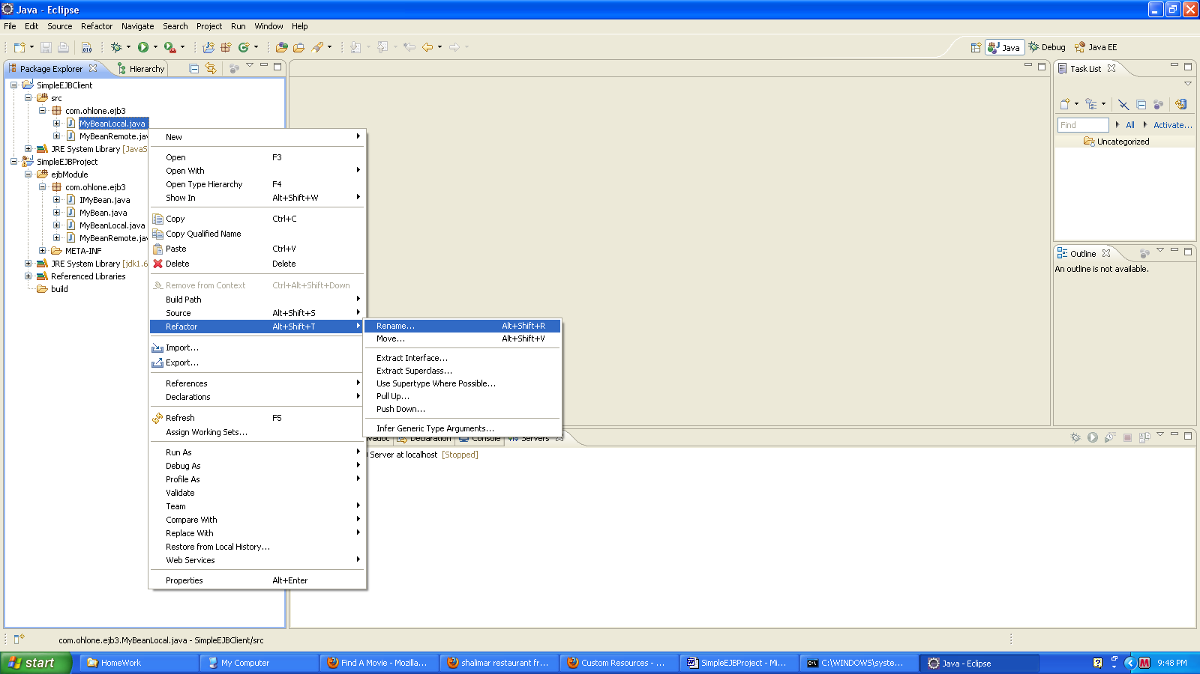

package com.ohlone.ejb3;

public interface MyBean {
public String doSomething();
}

package com.ohlone.ejb3;

public interface MyBeanRemote extends MyBean{

}

package com.ohlone.ejb3;

import javax.naming.InitialContext;
import javax.naming.NamingException;

public class EJBClientTest {

/**
* @param args
*/
public static void main(String[] args) {
// TODO Auto-generated method stub
String str;
try {
InitialContext ctx = new InitialContext();
MyBeanRemote bean = (MyBeanRemote) ctx.lookup("ejb/MyBeanJNDI");
str = bean.doSomething();
System.out.println(str);
} catch (NamingException e) {
e.printStackTrace();
}
}
}

